

CSA0501-DATABASE MANAGEMENT SYSTEMS

LAB EXPERIMENTS DATE: 14/07/2026

EXPERIMENT 5 – SELECT with various clause – WHERE, pattern matching

AIM: To view the records from the tables using SELECT commands with WHERE Clause and Pattern matching.

PROCEDURE:

Open MySQL and select the Pet Management System database.

Ensure the pet_details table contains records.

Use the SELECT statement with the WHERE clause to filter records.

Use the LIKE operator with % and _ wildcards for pattern matching.

Execute each query and verify the displayed records.

Observe the output and ensure the queries execute successfully.

PROGRAM:

1. Display all records:

USE pet_management;

SELECT * FROM pet_details;

OUTPUT:

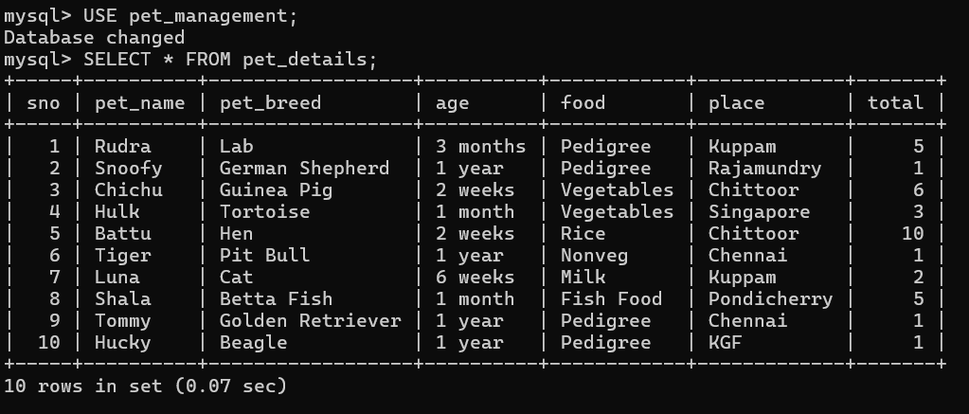

2. WHERE Clause – Display pets from Chennai:
SELECT * FROM pet_details
WHERE place = 'Chennai';

OUTPUT:

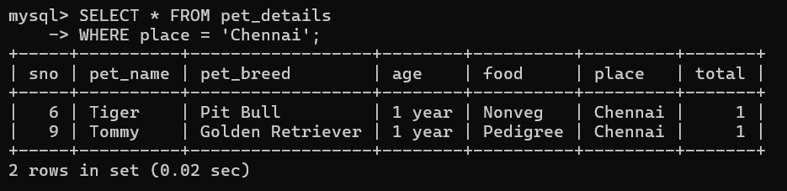

3. WHERE Clause – Display pets whose food is Pedigree

SELECT * FROM pet_details
WHERE food = 'Pedigree';
OUTPUT:

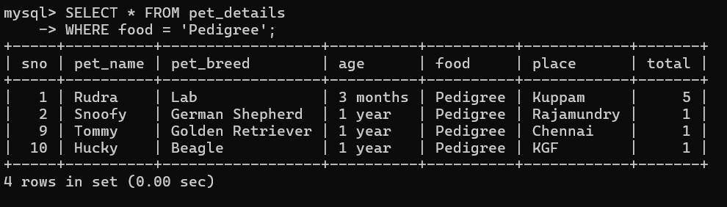
4. LIKE (%) – Display pet names starting with 'R':

SELECT * FROM pet_details
WHERE pet_name LIKE 'R%';

OUTPUT:

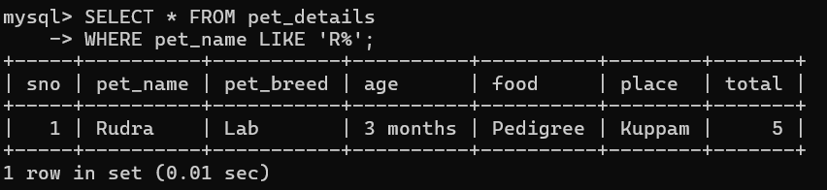

5. LIKE (%) – Display places ending with 'pur':
SELECT * FROM pet_details
WHERE place LIKE '%pur';
OUTPUT:

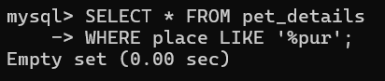
6.LIKE (_) – Display pet names with exactly 5 letters:
SELECT * FROM pet_details
WHERE pet_name LIKE '_____';
OUTPUT:
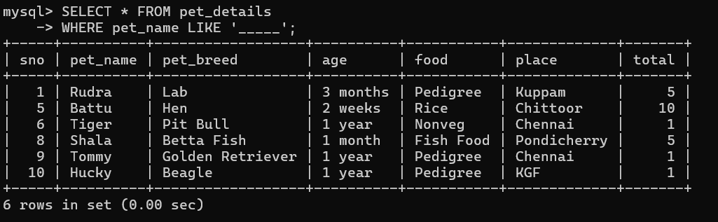
7.WHERE Clause – Display pets whose total is greater than 2:
SELECT * FROM pet_details
WHERE total > 2;
OUTPUT:
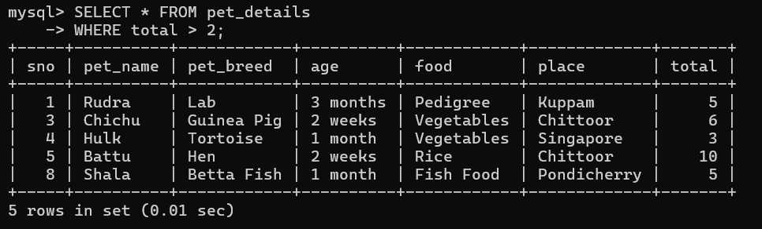
RESULT: The records from the tables are displayed using SELECT commands with WHERE Clause and Pattern matching.

